**this**

 this is a keyword that refers to the **current instance of the class**.

The following are common uses of this:

* To qualify members hidden by similar names, for example:

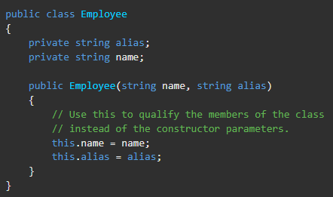

* To pass an object as a parameter to other methods, for example:



* To declare indexers, for example:

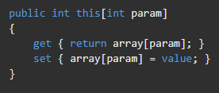

**Static member functions**, because they exist at the class level and not as part of an object, **do not have this pointer**.

It is **an error** to refer to this in a static method.

**base**

The base keyword is used to access members of the base class from within a derived class:

* Call a method on the base class that has been overridden by another method.

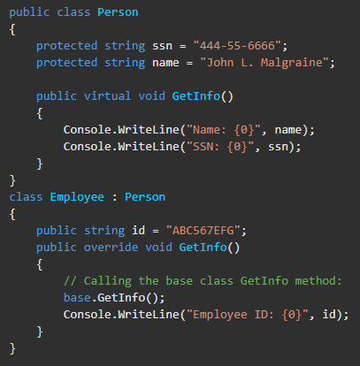

* Specify which base-class constructor should be called when creating instances of the derived class.

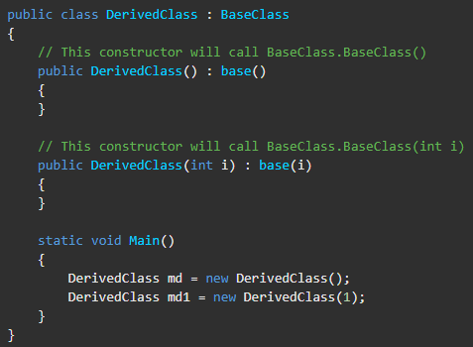

It is an **error** to use the base keyword from within a static method.